Big Green Practice Bot Mapping

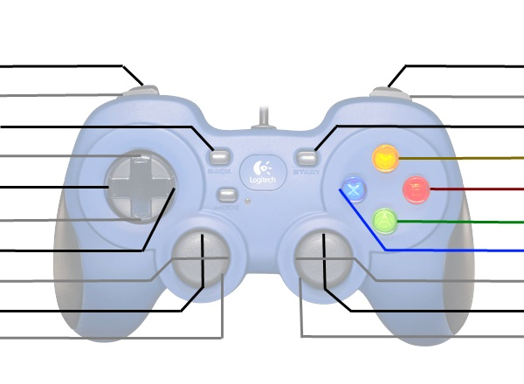

Left Drive Motor

Intake In/Out

Jaws Up/Down

Jaws Open/Close

Intake Arms

Shifter

Right Drive Motor

Lift Up/Down